

Computer science Project
Session: 2025-2026

A Project Report On “Snake Game”

Submitted By- Under The Guidance Of:
Jatan Sanjay Thanki Mrs. Bhavnita Postaria
Krishna Pancholi (PGT Computer Science)
Class XII (Science A)

Contents
S.No. | Description | Pg.No.
1. | Certificate | 3
2. | Acknowledgement | 4
3. | Introduction | 5
4. | Python Overview | 6
5. | Features of Python | 7
6. | Installing Python | 8-9
7. | About MySQL | 10
8. | Advantages Of Snake Game | 11
9. | Rules of Snake Game | 12
10. | Objectives | 13
11. | Source Code | 14-15
12. | Output | 16-18
13. | Bibliography | 19
14. | Requirements | 20

Certificate

This is to certify that Jatan Sanjay Thanki and Krishna Pancholi, students of Class XII (Science) have successfully prepared the report on the Project entitled “Snake Game” under the guidance of Mrs. Bhavnita Postaria (PGT Computer Science). The report is the result of their efforts & endeavours. The report is found worthy of acceptance as final Project report for the subject Computer Science of class XII (Science).

_________________________ _________________________
Signature of Internal Examiner Signature of External Examiner

_________________________
Signature of Principal

Acknowledgement

We would like to express a deep sense of thanks and gratitude to our project guide Mrs. Bhavnita Postaria for guiding us immensely through the course of the project. She always evinced keen interest in our project. Her constructive advice & constant motivation have been responsible for the successful completion of this project.

Our sincere gratitude goes to Mrs.Lincy Pancholi (Principal) madam for her coordination in extending every possible support for the completion of this project.

We must thank our classmates for their timely help and support for completion of this project.

Last but not the least, We would like to thank all those who had helped directly or indirectly towards the completion of this project.

Jatan Sanjay Thanki
Krishna Pancholi
Class- XII (Science)

Introduction

The Snake Game is one of the most classic and popular arcade games ever created. In this project, I have recreated the Snake Game using Python, along with SQL database connectivity to store and manage player information such as high scores. The main objective of the game is simple: control the snake, eat food, and grow longer without hitting the walls or your own tail. Despite its simplicity, the game develops logical thinking, improves concentration, and is a great way to apply programming concepts.
This project demonstrates how traditional game logic can be combined with database management to create a more interactive and functional application. By integrating SQL, the game becomes capable of storing scores permanently, allowing multiple players to track their performance over time.

Python Overview
Python is a high-level, interpreted programming language renowned for its exceptional readability and simplicity. Created by Guido van Rossum in 1991, it emphasizes code clarity through its clean, English-like syntax and significant use of whitespace. Python follows the philosophy that "there should be one—and preferably only one—obvious way to do it," making it an excellent choice for beginners while remaining powerful enough for professional developers.
The language features dynamic typing and automatic memory management through garbage collection, allowing programmers to focus on problem-solving rather than low-level details. Python supports multiple programming paradigms including object-oriented, procedural, and functional programming styles. Its extensive standard library, often described as "batteries included," provides modules for everything from file I/O and regular expressions to web servers and testing frameworks.
Python's versatility spans numerous domains including web development (Django, Flask), data science (Pandas, NumPy), artificial intelligence (TensorFlow, PyTorch), scientific computing, automation, and scripting. The language uses an interpreter that executes code directly, though it first compiles source code to bytecode for improved performance. Python's package ecosystem, managed through pip and the Python Package Index (PyPI), contains over 400,000 libraries, making it one of the most comprehensive programming ecosystems available.
Python's continued evolution, combined with its gentle learning curve and powerful capabilities, has maintained its position as one of the world's most popular and widely adopted programming languages across education, industry, and research.

Python Features
- Simple & Readable
  - Clean, English-like syntax
  - Easy to learn and write
- Interpreted Language
  - No compilation needed
  - Immediate code execution
- Dynamically Typed
  - No type declarations required
  - Flexible variable usage
- Versatile Applications
  - Web development
  - Data science & AI
  - Automation & scripting
- Extensive Libraries
  - Rich standard library
  - 400,000+ PyPI packages
- Cross-Platform
  - Works on all major OS
  - Write once, run anywhere
- Object-Oriented
  - Supports OOP principles
  - Classes and inheritance
- Free & Open Source
  - No cost
  - Community-driven
- Great Community
  - Strong support
  - Regular updates
Installing Python

Step 1: Download Python
- Visit the official Python website: python.org/downloads
- Click the download button for the latest stable version for your operating system (Windows, macOS, or Linux).

Step 2: Run the Installer
- For Windows:
  - Run the downloaded .exe file.
  - Crucial: Check the box at the bottom that says "Add Python to PATH".
  - Select "Install Now" for a standard setup.
  - Follow the prompts to complete installation.

- For macOS:
  - Open the downloaded .pkg file.
  - Follow the on-screen installation instructions.
  - The installer will set up Python and necessary tools.

- For Linux (Ubuntu/Debian):
  - Python is often pre-installed. To ensure you have it or to update:
  - Open a Terminal.
  - Run the command: sudo apt update && sudo apt install python3

Step 3: Verify Installation
- Open a new Command Prompt (Windows) or Terminal (macOS/Linux).
- Type the command: python --version or python3 --version
- If installed correctly, you will see a version number like "Python 3.11.5".

Step 4: Next Steps
- Start the Python interactive interpreter by typing python or python3 in your terminal.
- Write your first script in a simple text editor and run it from the terminal.
- Explore the built-in Integrated Development Environment (IDLE) that installs with Python on Windows/macOS.

About MySQL

MySQL is a powerful and widely adopted open-source relational database management system (RDBMS) that uses Structured Query Language (SQL) for accessing and managing data. Developed, distributed, and supported by Oracle Corporation, it is a core component of the popular LAMP (Linux, Apache, MySQL, PHP/Perl/Python) web application software stack. As a relational database, MySQL organizes data into one or more tables in which data types may be related to each other, helping structure the data and enforcing rules to maintain data integrity and consistency.

The system is known for its reliability, scalability, and ease of use, making it a popular choice for everything from small personal projects to large-scale, high-traffic websites and enterprise applications. It operates on a client-server model, where the database server handles commands sent from multiple client programs. Key features include strong data protection, comprehensive application development support, and the ability to handle large volumes of data efficiently. Its open-source nature means it is free to use and modify, supported by a large and active community, which has contributed to its widespread adoption across various industries.

Advantages
of “Snake Game”
The Snake Game offers several advantages that make it both educational and entertaining. It helps improve a player's concentration, reflexes, and hand–eye coordination as the snake moves faster and requires quick decisions. For students and developers, creating a Snake Game is a great way to learn important programming concepts such as game loops, event handling, collision detection, and graphical interface design. When combined with database connectivity, it also teaches practical skills like storing and retrieving data, managing high scores, and integrating Python with SQL. Overall, the Snake Game is simple yet effective in enhancing logical thinking, problem-solving skills, and programming knowledge.
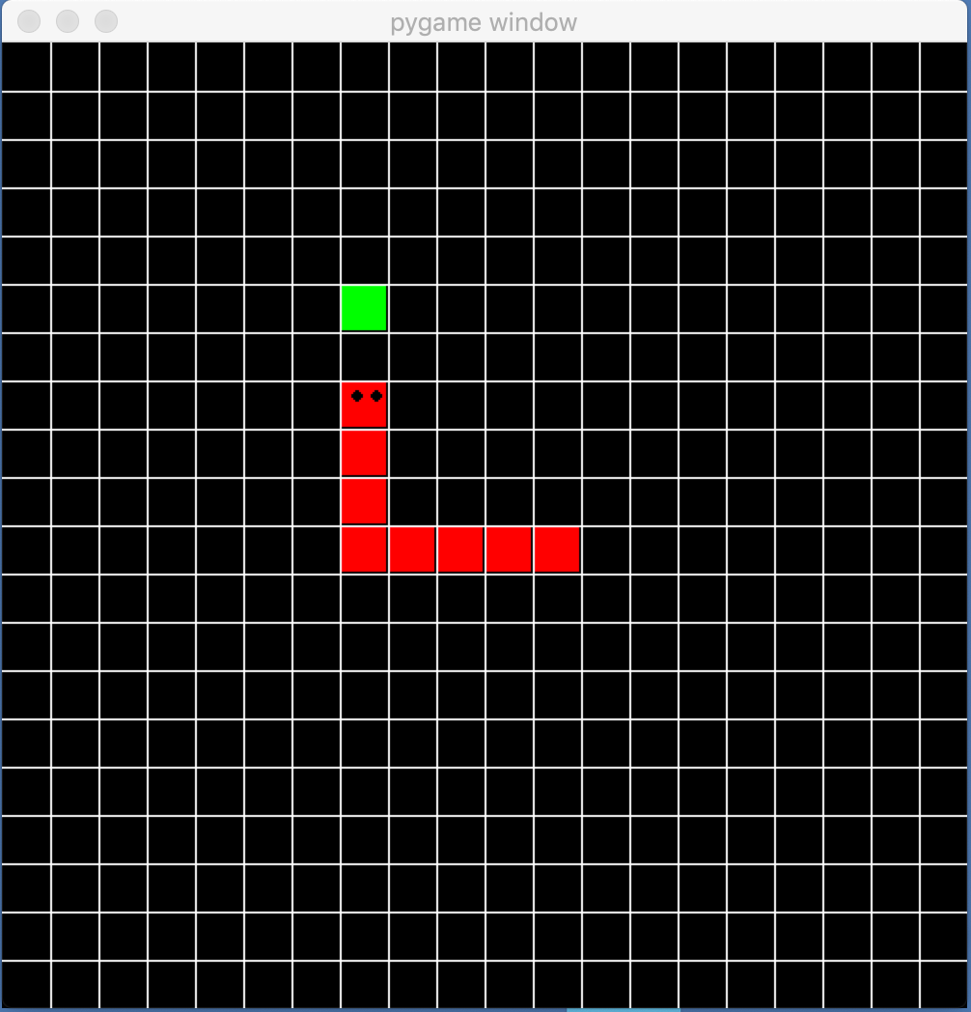

Rules of the Game

The Snake Game follows a few basic rules that guide how the player interacts with the game. The player controls the snake using arrow keys, and the snake must move continuously without stopping. The main goal is to eat the food that appears on the screen, which increases the snake’s length and the player’s score. However, the game ends immediately if the snake collides with the boundary walls or runs into its own body. The player cannot move the snake in the opposite direction instantly (for example, moving directly from left to right). As the snake grows longer, controlling it becomes more challenging, making the game progressively harder and more exciting.

Objectives

- To develop a simple yet engaging game using Python.
- To understand fundamental game development concepts such as:
  - Graphics rendering
  - Event handling
  - Collision detection
  - Game loops

- To implement SQL connectivity for storing and retrieving high scores.
- To gain hands-on experience in combining Python programming with database management.
- To create a user-friendly project suitable for academic demonstration.


Source Code
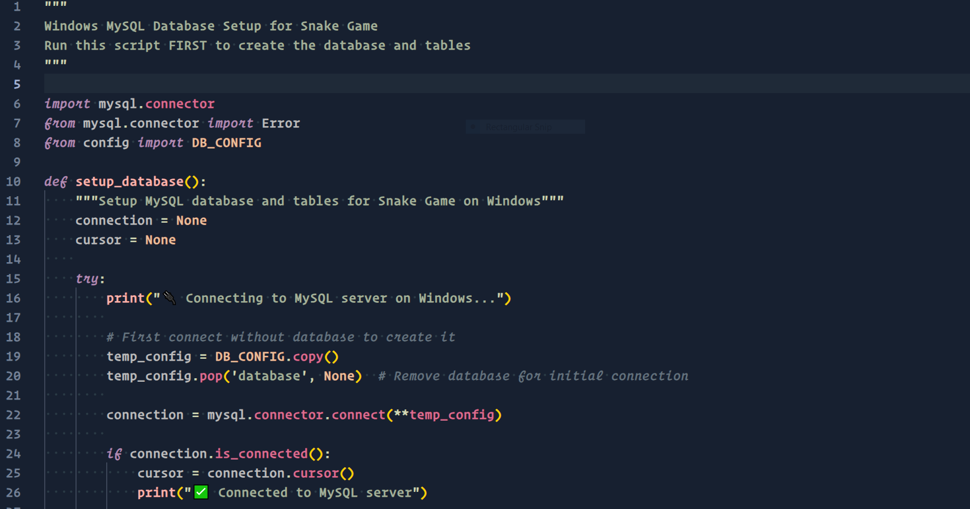

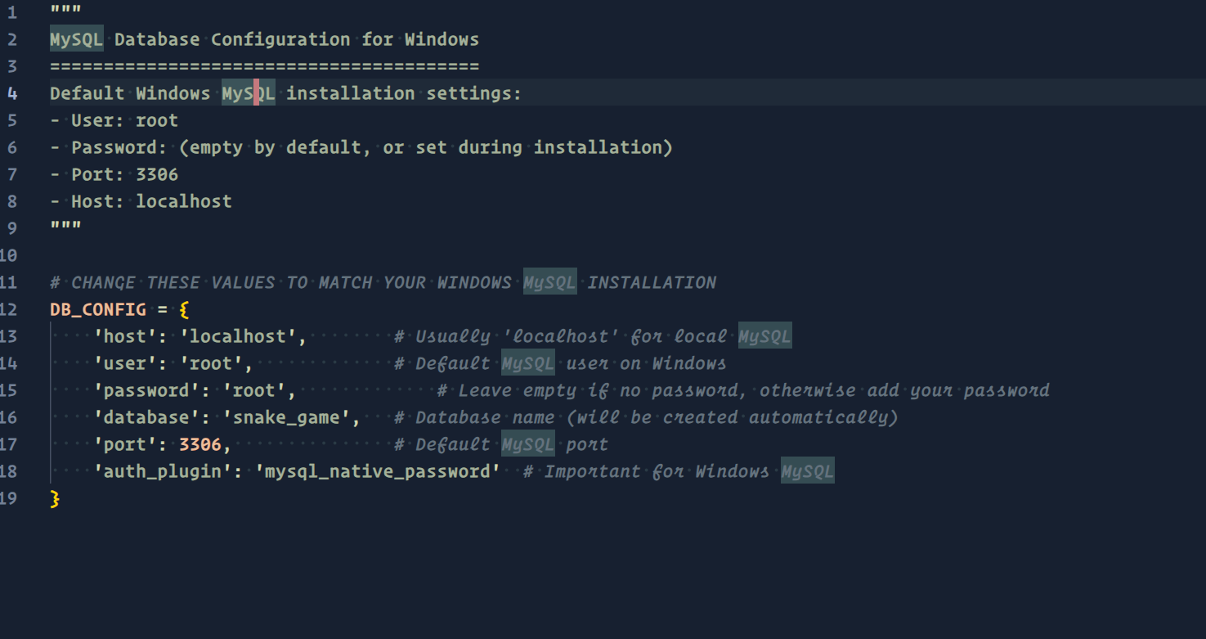
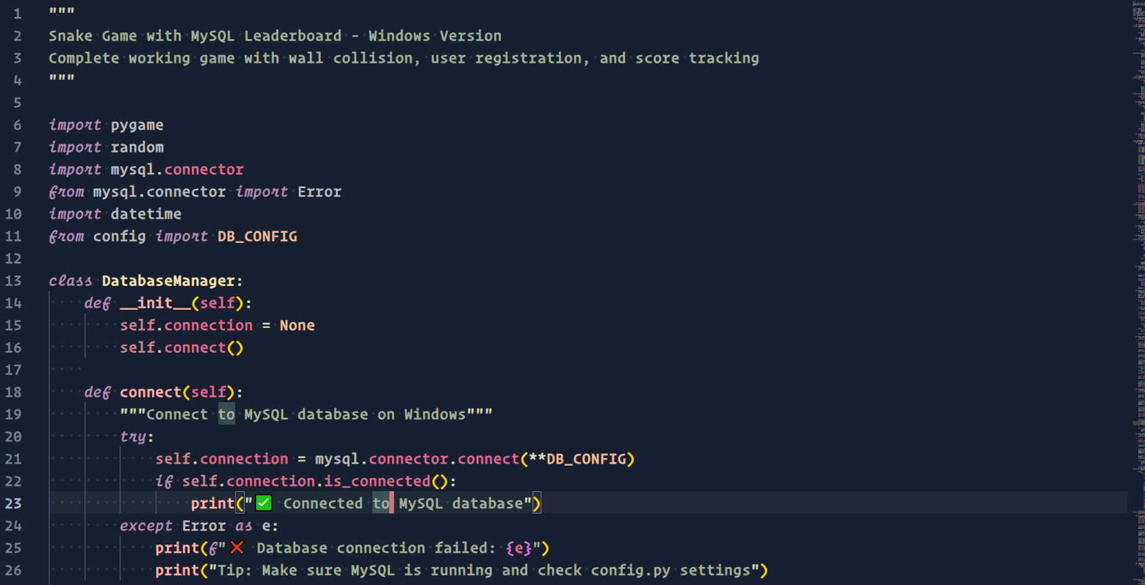

Output

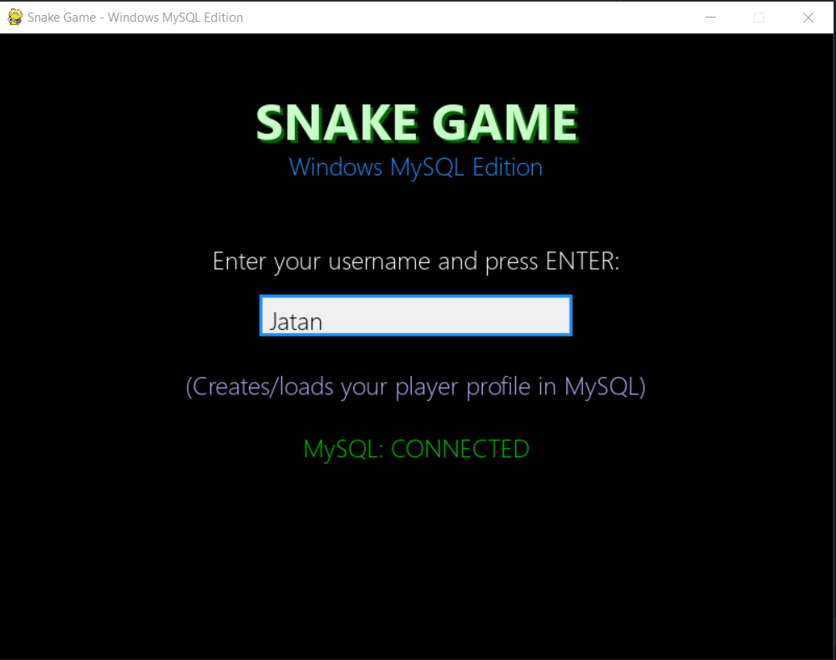

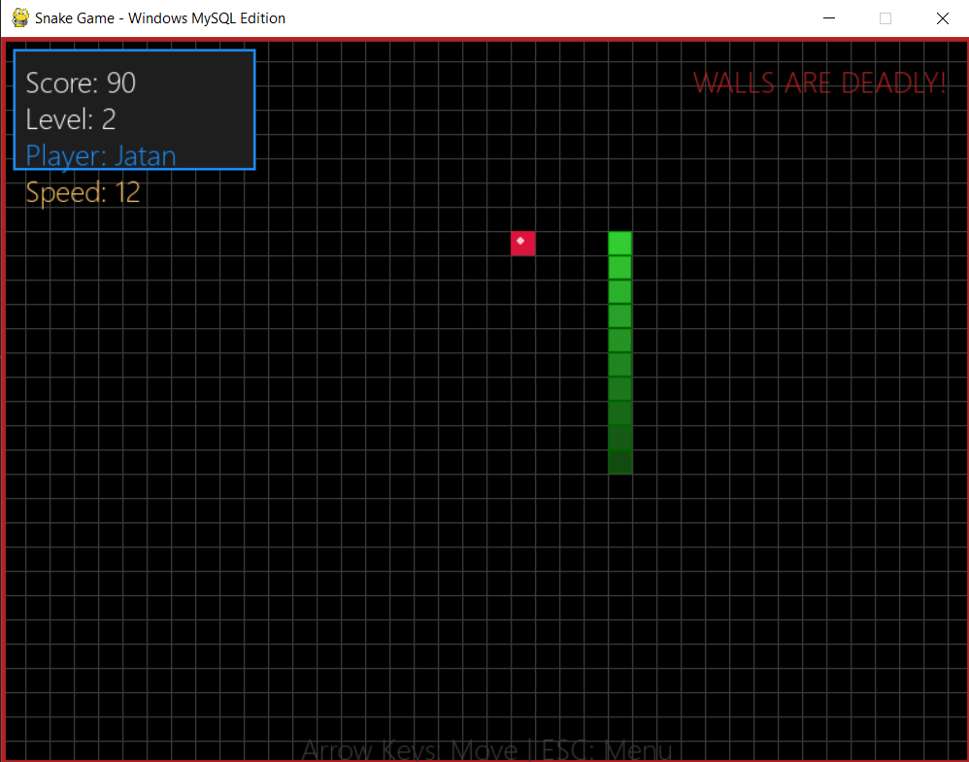

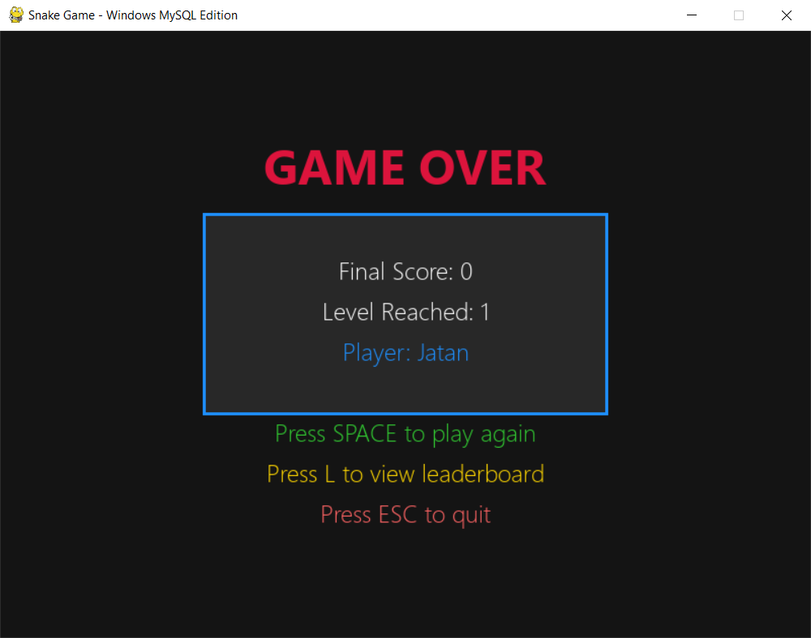

Bibliography

- Python Documentation
- Pygame module documentation
- Youtube Tutorials (Code with Harry)
- Geeks For Geeks

Requirements

Hardware required: -
64-bit operating system, x64-based processor
Intel(R) Core (TM) i3 CPU or better equivalent processor
Minimum 4GB RAM

Software required: -
Windows 11 or 10
A preferable text editor (Neovim or VS Code)
Python 3.13.5
MySQL



